

KENYAHIGHSCHOOL



SCHOOLCATEGORY: GIRLS {}

BOYS {} MIXED{}

THENATIONALCHEMISTRYCONTEST1STEDITION

**FORM4**

# 233Chemistry

**8THJune,2024 Time: 11/2Hours**

NAME:………………………………………….…….……CODE………….…………

InstructionstoCandidates

1. Write your Name and the Code in the spaces provided above.
2. Indicate the School category in the space provided above
3. Answer ALL the questions in the Answer Sheet provided.
4. Mathematical tables and silent electronic calculators may be used.
5. This paper consists of 10 printed pages

**ForExaminer’sUseOnly**

|  |  |  |
| --- | --- | --- |
| **Questions** | **Max.Score** | **Candidate’sScore** |
| **1–23** | **55** |  |

***©KHS/CHEMDEPT/T2/2024***

## SECTION A

* 1. Tri-Irontetraoxide isanoxide ofironwhich canbeproduced inthelaboratory.
     1. Writean equationfor thereaction whichcanbeusedto producethe oxide.(1mks)
     2. Writeanequationforthe reactionbetweentheoxide andhydrochloricacid.(1 mks)
  2. Statethe advantageof usingaboilingtube whileheatingcomparedto a test tube.(1/2mks)
  3. Whenpreparinga gas inthelaboratory,explainwhythefollowingis done.
     1. Heatingisnot requiredwhenusingaflat-bottomed flask, (1/2mks)
     2. Thedeliverytubemustalwaysbewellabovethelevelofthereactingchemicals. Ifthetubetosupplya liquid or solution reagent is a dropping funnel, the tap must be closed. (1/2mks)
     3. If athistlefunnel isused, itmust bedippedbelowthe surfaceofthe reactingchemicals.(1/2mks)
  4. Completethe**Table1** below;

|  |  |  |  |
| --- | --- | --- | --- |
| **Volume(cm3)** | **360** | **27** |  |
| **Temperature(oC)** | **27** |  | **360** |

### Table 1

* 1. ElementXreactswithdiluteacidsbutnotwithcoldwater.ElementYdoesnotreactwithdiluteacids. Elements Z displaces element W from its oxide. W reacts with cold water. Name the element that is likely to have the largest atomic radius. (1 mk)
  2. Startingwith2Msodiumhydroxidesolution,describehow youcanpreparecrystalsofanacidsalt formed when sodium hydroxide reacts with 2M sulphuric (VI) acid. (3 mks)
  3. Determinethemolecularmassofthe gasBwhichdiffuses½timesfasterthanOxygen.(1mks)
  4. Thegraphbelowshowstherelationshipbetweenpressureandthetemperatureofagasinafixed volume container.

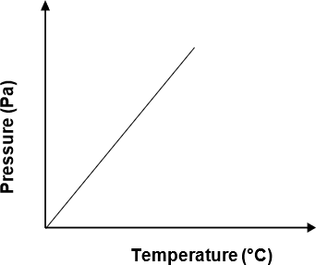

Statetherelationshipbetweenpressureandtemperaturethatcanbedrawn fromthe graph.(1/2mks)

* 1. **RCOO-Na+**and**ROSO3-Na+**aretypesof cleansingagents;
     1. Nametheclassof cleansingagentstowhich eachbelongs. (1 mks)
     2. Whichoneoftheseagentsin(a)abovewouldbemoresuitablewhenwashingwithwaterfromthe Indian Ocean. Explain. (1 mks)
  2. ThemolecularmassofgasFis 28and its empiricalformulais𝐶𝐻2.
     1. DeterminethemolecularformulaofF.(1mks)
     2. (i)Writethestructural formula ofF.(1/2mks)
        1. WriteequationforthereactionbetweenFand brominewater.(1 mks)
     3. (i)Name oneotherreagent thatcan beused to identify F. (1 mks)
        1. Statewhat would beobserved if thereagentis used onF.(1 mks)
  3. Undersuitablelaboratoryconditionsethenecanbeconvertedtoacompoundwithageneralformula (−𝐻2𝐶−𝐶𝐻2−). Name one other compound of the category (−𝐻2𝐶−𝐶𝐻2−)which is:

1. Manmade.(1/2mks)
2. Notmanmade. (1/2mks)
   1. Substances**G**and**H**arerepresentedbytheformulae**ROH**and**RCOOH**respectively.Theybelongto two different homologous series of organic compounds. If both G and H react with potassium metal:

Statetheobservationmadewheneachofthesamples **G**and**H**arereactedwithasodiumhydrogen carbonate. (1 mks)

* 1. Explainwhydilute Sulphuricacid is astrongacidthan concentrated Sulphuricacid.(1 mks)
  2. Explainwhyparticles collideand products areformed during achemical reaction.(1 mks)
  3. Explainwhatwouldhappentothepositionofequilibriuminthefollowingreactionifthepressureis increased. (2 mks)

**CaCO3(s)⇌CaO(s)+CO2(g) ΔH=+vekJmol-1**

* 1. Thegraphbelow showsthe variationofvolumeof hydrogen withtimewhen excessmagnesium was

addedto 100cm3 of 1.0Msulphuricacidat roomtemperature.

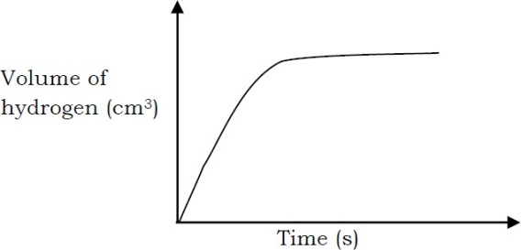

*Sketch*onthesameaxesofthegraphinthefigure and*label*,thegraphthat wouldbeobtainedifthefollowing were used at room temperature: (1 mks)

(i)100cm3of0.5M sulphuric acid. (ii)200cm3of 2.0M sulphuric acid.

## SECTION B

* 1. Carbonburnsin oxygenaccordingto the followingequation

**C(𝑠)+𝑂2(𝑔)→𝐶𝑂2(𝑔) Δ𝐻=−393𝑘𝐽𝑚𝑜𝑙−1**

* + 1. Calculatethe

1. Amountof heat evolvedwhen 5.6gcarbonis burnt completelyin oxygen.(1 mks)
2. Volumeofoxygenats.t.pthatwouldberequired toproduce78.6kJ ofheat.(*1moleofgas occupies 22.4 dm3 at s.t.p*) (1 mks)
   * 1. Calculatetheenthalpyofhydrationofbromideionsgiventhefollowing. Enthalpy of hydration of magnesium ions **– 1,891kJ/mol**

Latticeenergyof MgBr2**-2,421kJ/mol**

Enthalpyof solution ofMgBr2**– 186kJ/mol** (1mks)

* + 1. ExplainwhythemolarheatofneutralizationofKOHandethanoicacidofequalvolumeandmolarity would be less than the value obtained in the molar heat of neutralization of KOH and sulphuric (VI) acid.(1 mks)
  1. (a) A piece of iron wire of mass 2.225g was put into a conical flask containing dilute sulphuric (VI) acid.TheflaskwasfittedwithabungcarryingaBunsenvalve,toallowthehydrogengasgeneratedto escape but prevent air from entering. The mixture was warmed. When the effervescence stopped, the

solution was cooled to room temperature and made up to 250cm3 in a graduated flask. 25cm3 of the solutionwereacidifiedandtitratedagainsta0.0185moldm-3solutionofpotassiumdichromate(VI) the volume required was 31cm3. Calculate the percentage of iron in the iron wire. (1 mks)

(b) A sample containing ammonium sulphate was warmed with 250cm3 of 0.8moldm-3 sodium hydroxidesolution.Aftertheevolutionofammoniahadceased,thesolutionwasneutralizedby85cm3 of hydrochloric acid of concentration 0.5moldm-3. What mass of ammonium sulphate did the sample contain? (1 mks)

* 1. (a)5.125gofwashingsodacrystalsaredissolvedandmadeupto250cm3ofsolution.A25cm3portion requires 35.8cm3 of 0.05moldm-3 sulphuric (VI) acid for neutralization. Calculate the percentage of sodium carbonate in the crystals. (1 mks)

(b)From23gofethanol, 36gofethyl ethanoateareobtainedbyesterificationwithethanoicacidinthe presence of concentrated sulphuric (VI) acid. What is the percentage yield of the reaction? (1 mks)

* 1. Thefollowing **Figure 1** shows thesteps in the manufactureofsulphuric acid bythe contact process

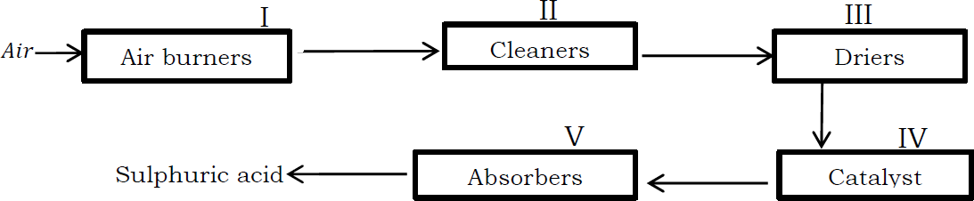

**Figure1**

1. Writeanequationfor thereactionthattakesplaceinstepI.(1 mks)
2. Whyis stepIInecessary?(1 mks
3. Namethe:
   1. DryingagentinstepIII.(1mks)(ii)CatalystinstepIV. (1/2mks)
4. Describethe processthat takesplaceinstep V in orderto producesulphuricacid. (1 mks)
5. Sulphur(IV)oxide combineswith airtoform sulphur(VI) oxide.
   1. Writeequationforthereaction.(1mks)
   2. Statetheconditionsforthemaximumyieldof sulphur(VI)oxide.(1mks)
   3. 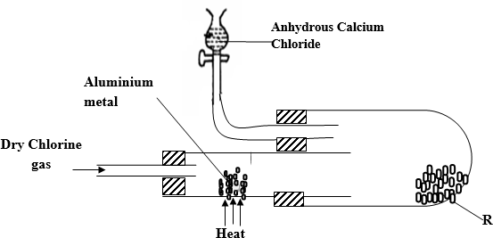Inanexperiment, drychlorinegas wasreacted withaluminium asshown inthe**Figure2** below.
6. NamesubstanceR. (1/2mks)

### Figure2

1. Writeanequation forthe reactionthat tookplaceinthe combustiontube.(1mks)
2. Statethefunction oftheanhydrouscalcium chloridein theset-up above.(1mks)
3. Nameanothersubstancethatcan beusedinsteadofanhydrous calciumchloride.(1/2mks)
4. Whyis thesubstancenamed abovein (d)moresuitable than anhydrous calcium chloride?(1/2mks)
5. Nameanothermetalthatcanbeusedinsteadofaluminium.(1/2mks)
6. Whatpropertymakes substanceR tobecollectedintheflask?(1/2mks)
7. Writethe equation forthereaction between excess phosphorus and chlorine.(1 mks)
   1. Usethe data inthe**table2**below to answerthequestions that follow.

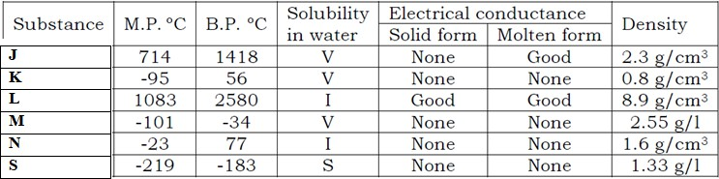

**Key**;

***V=Verysoluble***

***S=Slightlysoluble I=Insoluble***

**Table2**

* + 1. (i)Nametwosubstancesthatareliquidat roomtemperature.(1/2mks)

(ii)Whichofthetwo ismorevolatile?(1/2mks)

* + 1. Whichsubstanceswould dissolveinwaterandcould beseparatedfrom the solution by:
       1. Fractionaldistillation.(1/2mks)Byevaporationofthewater?(1/2mks)
    2. Which ofthesubstances:
       1. Hasthestructureconsistingof ions?(1/2mks)
       2. Is ametal?(1/2mks)
       3. Is aliquidwhichwouldformseparatelayerwithwater?(1/2mks)
       4. Wouldthewaterbeaboveorbelow?(1/2mks)
    3. Whichsubstanceis agaswhich:
       1. Wouldnot becollected efficientlyoverwater.(1/2mks)
       2. Wouldbe collectedefficientlyoverwater. (1/2mks)

## SECTION C

* 1. YouaregivensolidT(***aluminiumsulphate***).Carryoutthetestsbelowwritingobservationsandinfer accordingly. Take a spatula endful of T and put in a boiling tube.Add about 10cm3 of water and shake.Keep the mixture for the tests below.

1. Toabout2cm3ofsolutionT,addabout5dropsofNitricAcid(HNO3(aq))followedby2dropsof Barium nitrate.

|  |  |
| --- | --- |
| **Observations** | **Inference** |
|  |  |

1. Toabout2cm3 of solutionofTaddSodiumHydroxide (2MNaOH)dropwisetillinexcess.

|  |  |
| --- | --- |
| **Observations** | **Inference** |
|  |  |

1. Toabout2cm3 of solutionT,addAmmoniasolution(2MNH3(aq))drop wisetillinexcess.

|  |  |
| --- | --- |
| **Observations** | **Inference** |
|  |  |

WORKINGAREA



# WORKINGAREA



233ChemistryAnswerSheet

|  |  |  |  |  |
| --- | --- | --- | --- | --- |
| **QUESTION** | | **ANSWER** | **MARKS** | **TOTAL** |
| **1.** | (a) |  | (1mks) |  |
|  | (b) |  | (1mks) |  |
| **2.** |  |  | (1/2mks) |  |
| **3.** | (a) |  | (1/2mks) |  |
|  | (b) |  | (1/2mks) |  |
|  | (c) |  | (1/2mks) |  |
| **4.** |  |  | (1mks) |  |
| **5.** |  |  | (1mks) |  |
| **6.** |  |  | (3mks) |  |
| **7.** |  |  | (1mks) |  |
| **8.** |  |  | (1/2mks) |  |
| **9.** | (a) |  | (1mks) |  |
|  | (b) |  | (1mks) |  |
| **10.** | (a) |  | (1 mks) |  |
|  | (b)(i) |  | (1/2mks) |  |

|  |  |  |  |  |
| --- | --- | --- | --- | --- |
|  |  |  |  |  |
|  | (ii) |  | (1mks) |  |
|  | (c)(i) |  | (1mks) |  |
|  | (ii) |  | (1mks) |  |
| **11.** | (i) |  | (1/2mks) |  |
|  | (ii) |  | (1/2mks) |  |
| **12.** |  |  | (1mks) |  |
| **13.** |  |  | (1mks) |  |
| **14.** |  |  | (1mks) |  |
| **15.** |  |  | (2mks) |  |
| **16.** | (i) | **ONTHEGRAPH** | (1/2mks) |  |
|  | (ii) | (1/2mks) |  |
| **17.** | (a)(i) |  | (1mks) |  |
|  | (ii) |  | (1mks) |  |
|  | (b) |  | (1 mks) |  |
|  | (c) |  | (1mks) |  |
| **18.** | (a) |  | (1 mks) |  |

|  |  |  |  |  |
| --- | --- | --- | --- | --- |
|  | (b) |  | (1mks) |  |
| **19.** | (a) |  | (1 mks) |  |
|  | (b) |  | (1 mks) |  |
| **20.** | (a) |  | (1mks) |  |
|  | (b) |  | (1mks) |  |
|  | (c) (i) |  | (1 mks) |  |
|  | (ii) |  | (1/2mks) |  |
|  | (d) |  | (1mks) |  |
|  | (e)(i) |  | (1mks) |  |
|  | (ii) |  | (1mks) |  |
| **21.** | (a) |  | (1/2mks) |  |
|  | (b) |  | (1mks) |  |
|  | (c) |  | (1mks) |  |
|  | (d) |  | (1/2mks) |  |
|  | (e) |  | (1/2mks) |  |
|  | (f) |  | (1/2mks) |  |
|  | (g) |  | (1/2mks) |  |
|  | (h) |  | (1mks) |  |
| **22.** | (a) (i) |  | (1/2mks) |  |
|  | (ii) |  | (1/2mks) |  |
|  | (b)(i) |  | (1/2mks) |  |
|  | (ii) |  | (1/2mks) |  |
|  | (c)(i) |  | (1/2mks) |  |

|  |  |  |  |  |  |  |  |  |
| --- | --- | --- | --- | --- | --- | --- | --- | --- |
|  | (ii) |  | | | (1/2mks) |  | | |
|  | (iii) |  | | | (1/2mks) |  | | |
|  | (iv) |  | | | (1/2mks) |  | | |
|  | (d)(i) |  | | | (1/2mks) |  | | |
|  | (ii) |  | | | (1/2mks) |  | | |
| **23.** | (a) |  | **Observation** | **Inference** | (2mks) |  | |  |
|  |  |  |  | |
|  |  |  |  | |
|  | (b) |  | **Observation** | **Inference** | (2mks) |  |  | |
|  |  |  |  |
|  | (c) |  | **Observation** | **Inference** | (2mks) |  |  | |
|  |  |  |  |
|  |  |  | | |  |  | | |
| **TOTAL** | | | | | **55** |  | | |

*BELIEVETHATCHEMISTRYIS EASYANDYOUCAN PASS.SUCCESS*

**THIS ISTHELASTPRINTED PAGE**